- Accolade English Institute
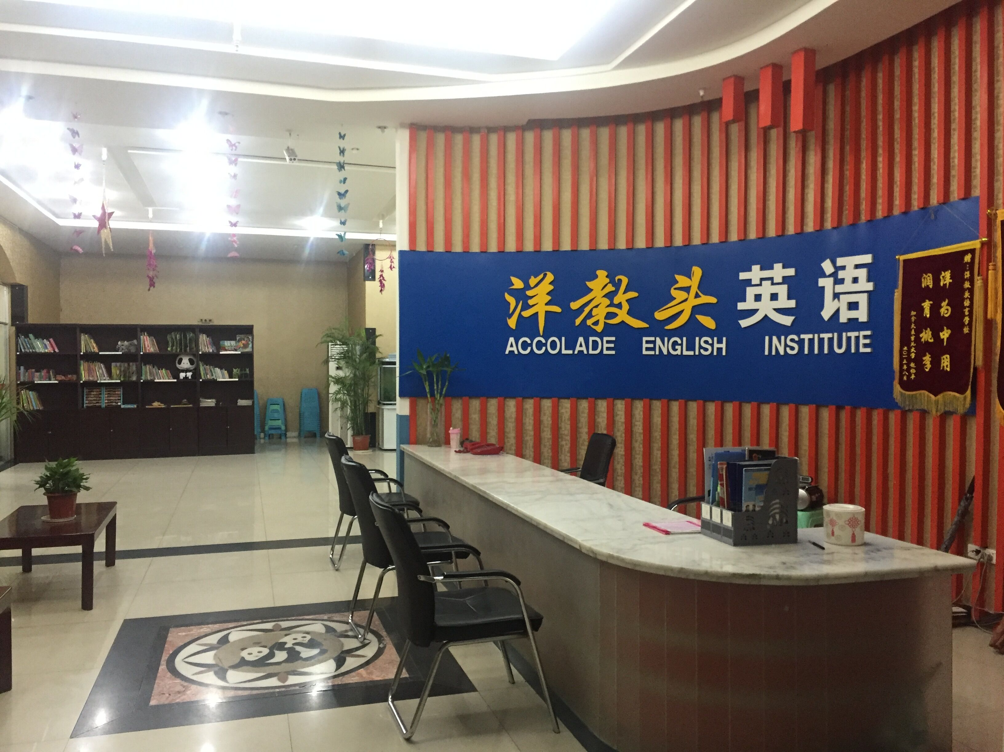
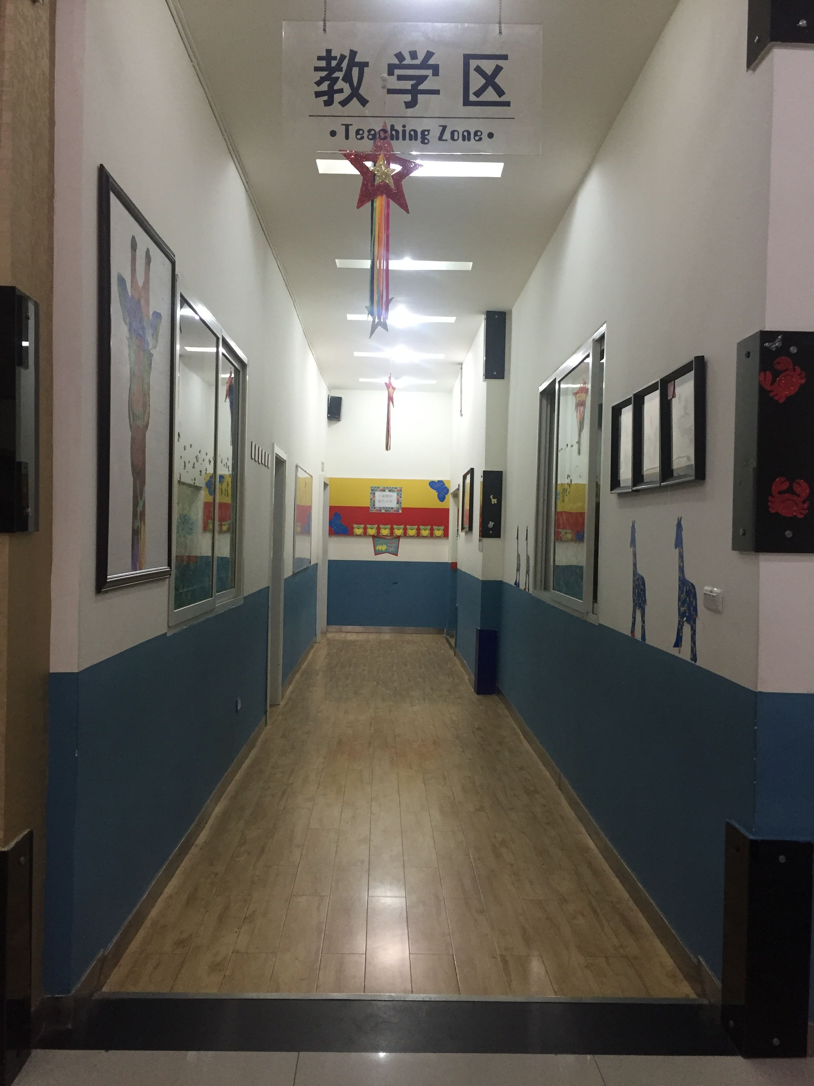
- Accolade English Institute was originally established in 2005, and is a foreign language training school that employs certified (Foreign Expert Certificate), experienced foreign teachers from English speaking countries. We also employ Chinese English majors with TEM-8 certification as teaching assistants.

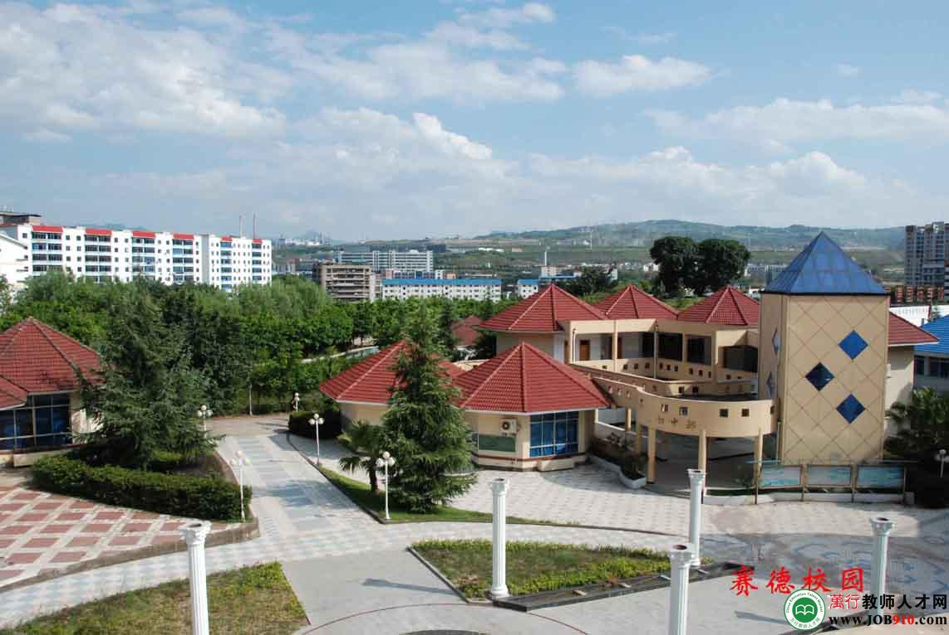
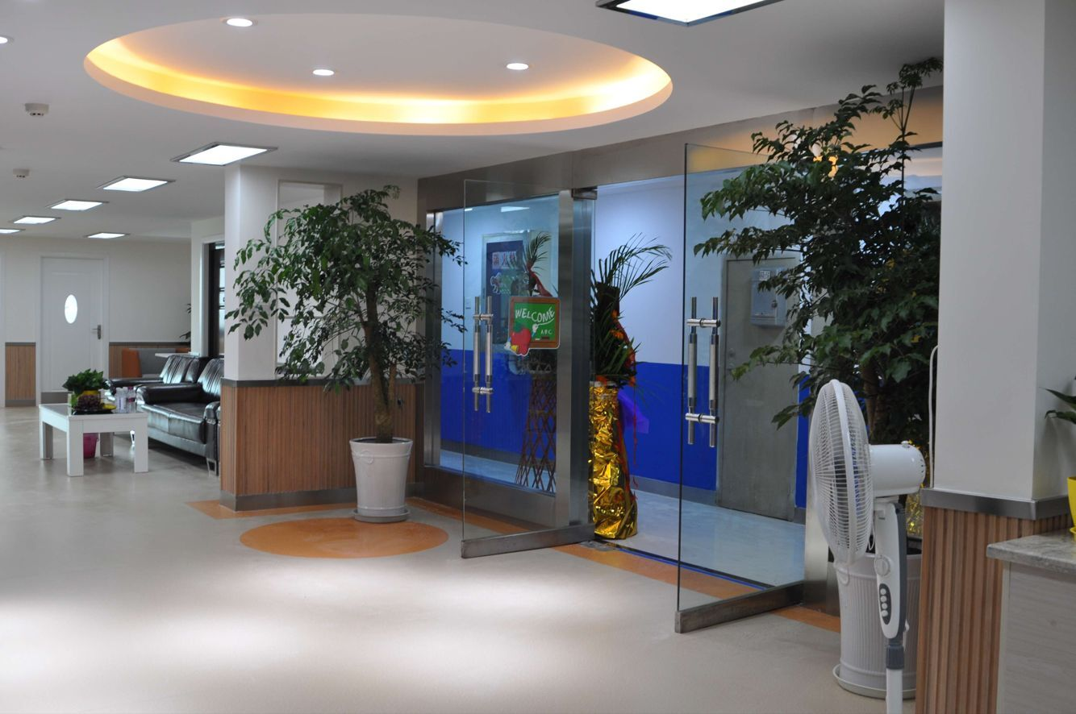

- Originally established in the CBD of Wanzhou, Accolade English Institute caters to students of all ages and levels, from kindergarten through to college/university and adult. As the only government licensed independent foreign language school in Wanzhou, Accolade English Institute legally employs the services of teaching professionals from all over the world. Accolade English Institute is committed to providing the best English education for Chinese students and the best working conditions for foreign teachers.
- Accolade English Institute is now at the forefront of quality English education in the entire Chongqing Municipality. We now have five branches in various locations, from
downtown Chongqing to its satellite cities, Wanzhou, Fuling, and Kaixian.


- Accolade English Institute also has partnerships with Saide International School and ChongQing Information Technology College, which means more teaching opportunities and experiences for foreign teachers.
- Accolade English Institute achievements over the past 5 years:

- From 2010 to 2013, Accolade English Institute students won first prize in the National English Contest for Primary Students.
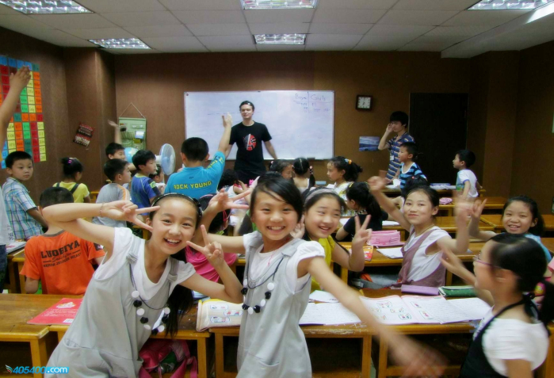
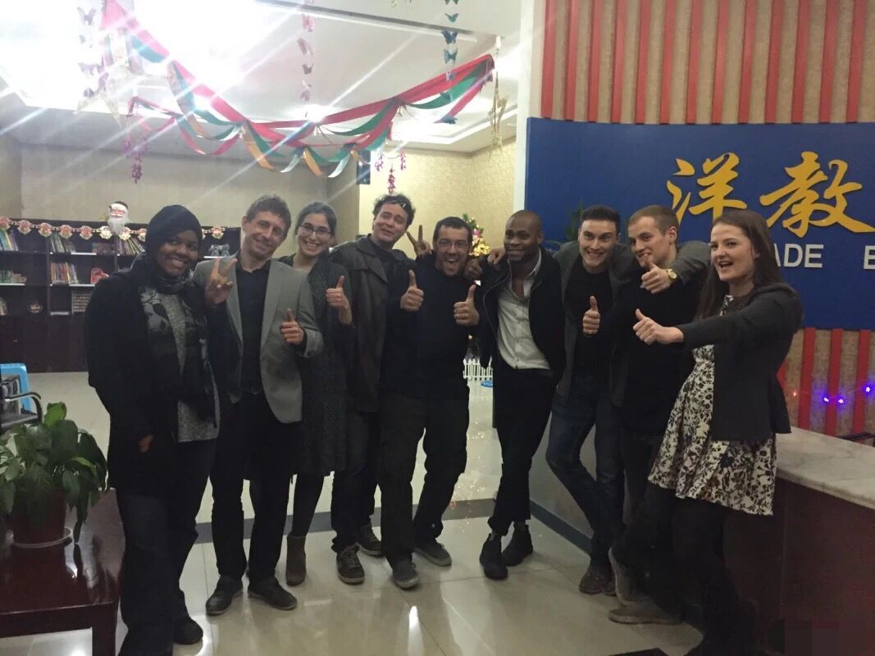
- From 2011 to 2014, Accolade English Institute students scored the highest on the Senior-High School Entrance Examinations, and were the highest achieving English students in Wanzhou.
- In 2011, Accolade English Institute undertook all the English training courses for the first peacekeeping contingent to Southern Sudan. These courses were organized by the Chongqing Public Security Bureau..
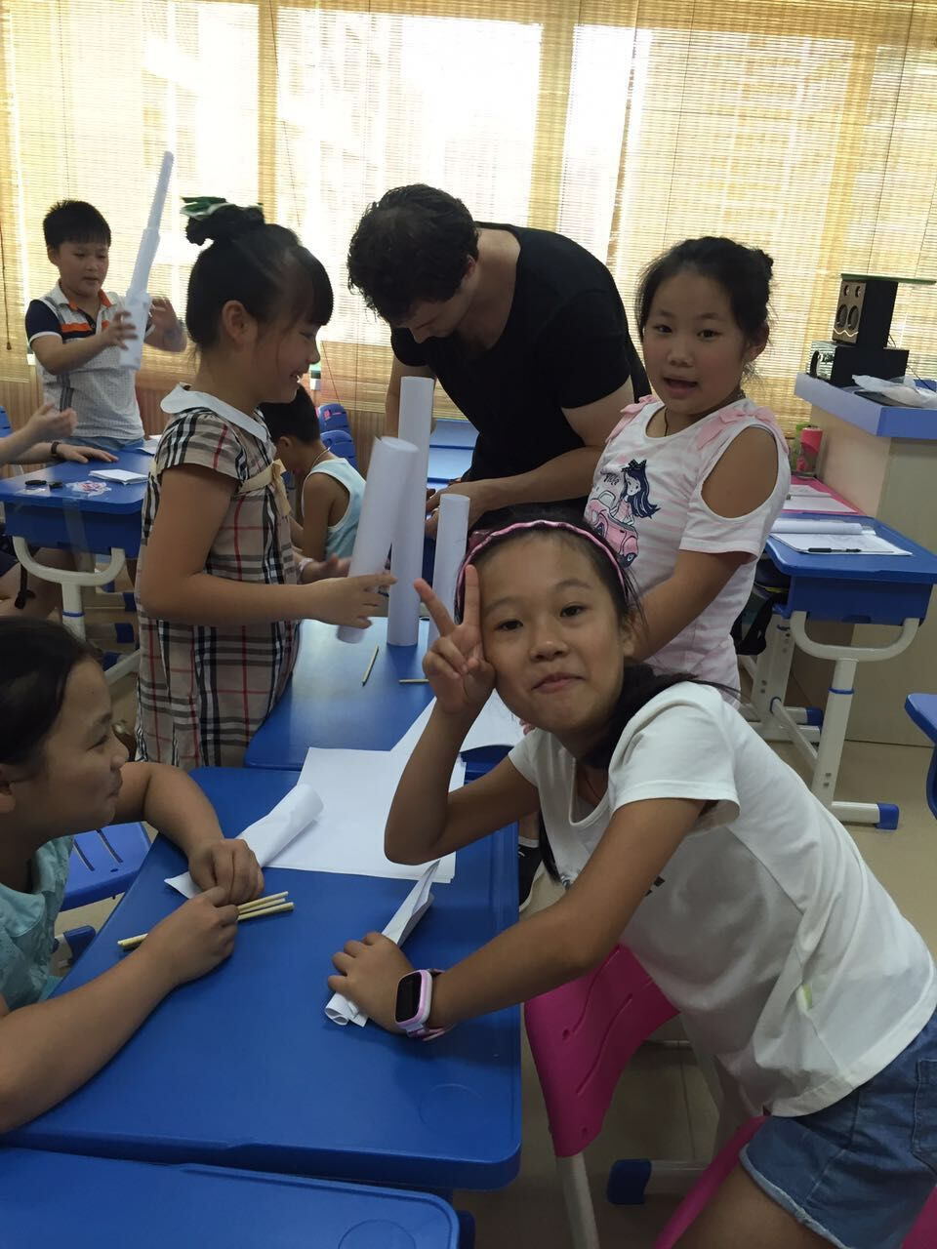
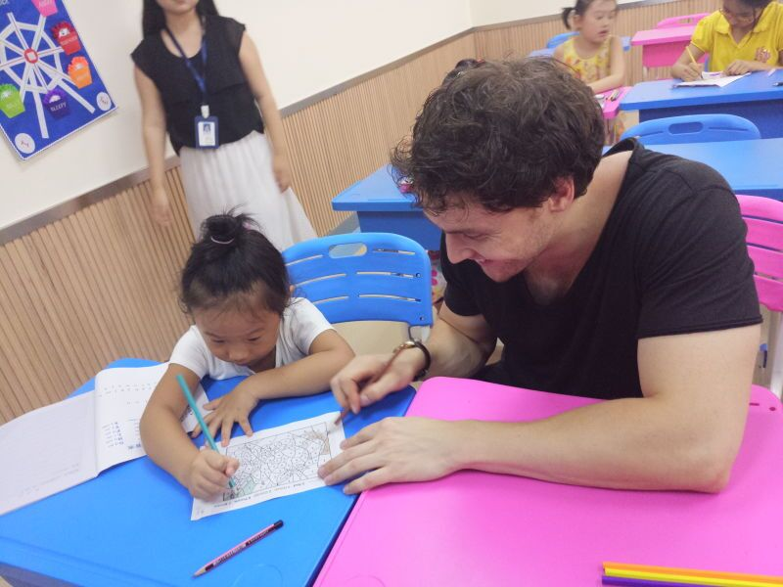
- In 2012, Accolade English Institute student, Wang Zhang Yu, achieved the highest grade in Wanzhou for the College Entrance Examinations. Wang Zhang Yu, a science student, was subsequently accepted into Tshinghua University. Another Accolade English Institute student, named Xiong Haifeng, was accepted into the University of Washington.
- In 2013, two Accolade English Institute students participated in CCTV’s “Star Of Outlook” English Talent Competition, and won the Chongqing Division championships in both primary and high school categories. They went on to make it to the top 20 and 50 respectively in the national finals. Several Accolade English Institute students were also accepted into Tsinghua University, Fudan University, Renmin University of China, the Central University Of Finance and Economics(CEFE), and Beijing Foreign Studies University, to name a few.
- In 2014, Accolade English Institute student, Zhao Xiping, was accepted into McGill University, which is one of the leading universities in Canada. Another student named Chenyu was accepted into Keele University.
- In 2015 and 2016, two Accolade English Institute students, Moon and Frank, won the primary and middle school Chongqing Division championships in CCTV’s “Star Of Outlook” English talent competition
- Life and cuisine in Chongqing, China.


- Chongqing cuisine is renowned for its spiciness and unique flavors.

- Some famous local dishes include hot-pot, dumplings, steamed meat, and spicy pork mince noodles.

- Wanzhou is also famous all over China for barbequed fish and Sichuan barbeque.



- Entertainment and lifestyle.

- Sports and activities, such as soccer, basketball, gymnastics, and even Chinese Kung Fu are very popular.


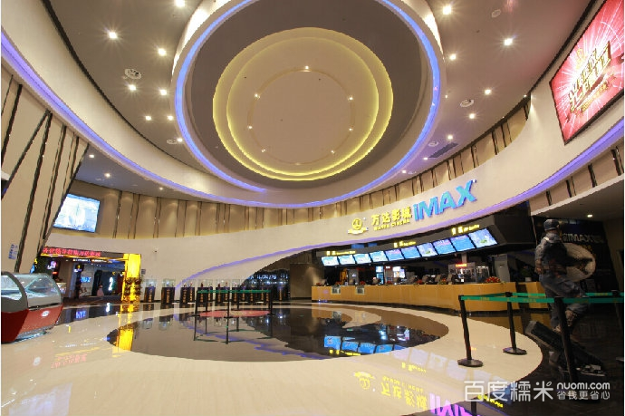
- Our Wanzhou branch is situated on the bank of the Yangtze River, the third longest river in the world. From here, The Three Gorges and other rich scenery and cultural experiences are easily accessible.

- Modern forms of entertainment, range from cinemas, shopping plazas, and bars to suit every taste.

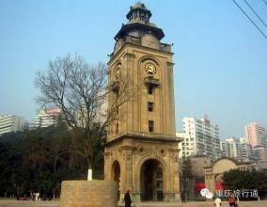

- ChongQing locals are open, friendly and curious about foreign visitors.

- A new language, and a new culture.

- Immerse yourself in a vibrant culture while mastering Mandarin, one of the most widely spoken languages in the world.


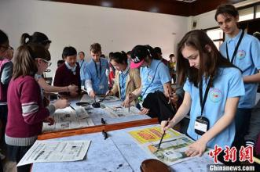

招聘启事
Teacher Recruitment Advertisement

- 岗位要求Requirements for Applicants:

性别Gender： ■不限Open
学历Education： ■本科Bachelor’s or above, in any discipline.
工作经验Work Experience： ■二年及二年以上Two years or above.
年龄Age： ■25-45 years old
国籍Nationality: ■母语（英国 UK，美国USA，澳大利亚Australia，加拿大Canada，新西兰New Zealand， 南非South Africa，爱尔兰Ireland）
语言Language: ■英语English (As the applicants first language, unless proficiency can be demonstrated during the interview process.)
人数Positions available: ■3人two
证书 Required certification: ■TEFL of CETL

- 外包合同内容 Contract Details

学校是否取得聘外资格证Is the school SAFEA authorized to employ foreign teachers?: ■是 yes □否 no
合同时间Contract time： ■一年one year
工作地点Working place： ■招聘单位所在地on campus ■招聘单位以外off campus
工作时间Workload:■25课时/周class per week （45分钟/课时45 minutes per class）
工资水平Salary: 10000~12000RMB/模拟谈话
课程设置Courses： Provided
饮食费用Meals：■提供炊具后自理Cooking utensils provided.
免费汉语课程Free Mandarin course： ■2－4课时/周 2－4 hours per week
住宿地点Boarding place： □校园内on campus ■校园外 off campus
交通方式Transport：■脚踏车 bike ■校车/公交车school bus/bus ■走路walk ■其他other
住宿环境Boarding： ■公寓apartment
外教公寓是否符合外专局标准Is the accommodation“FAO Approved”for foreigners?：■是yes
外教是否单独住一套公寓Is accommodation self-contained?: ■是yes
公寓面积The floor space： 50-70 平方米 （Square meter）
公寓内部情况:
■两卧室 Two bedrooms ■客厅 Sitting Room ■卫生间Bathroom/Toilet
■坐式马桶European Toilet ■厨房Kitchen ■淋浴/Shower
■彩电Color TV ■英语频道-中央9 (CCTV9) English Channel
■冰箱 Refrigerator ■全套家具 Complete set of furniture
■空调 Air conditioning ■洗衣/烘干设备Washing Machine
■电话Telephone(IDD) ■全天供应电/热水/24-hour supply of electricity/hot/water/gas
■微波炉或烤箱Microwave/oven ■影蝶机DVD player.
■室内用品：床，地毯，枕头，毛巾，拖鞋A-Z miscellaneous items(bedding and all required appliances)
■各式炊具盘子，玻璃杯子，茶杯，锅，平底锅 All kinds of cooking utensils.
■电脑（连接互连网）Computer with internet access provided, if required.
家属和朋友是否可以拜访Can relatives and friend visit the teacher at school:■是 yes
其他事宜Other items or conditions： ■ 可协商Negotiable

- 学校规模及周边设施 School Info. and Its Surroundings

学校规模 The size of the school：5 branches in 4 cities, 1 private college, and 1 associated full-grade school
是否寄宿 Does the school take boarders?：□是 yes ■否 no
学生人数Number of students： Over 2000 students in total.
教师人数Number of foreign teachers： 12
学生年龄Student age range： From 6 years old to adults.
班级大小Class size： 25-30 students
学生的英语程度Students’ English level： ■基础 Basic ■中级Intermediate ■高级 Advanced
周边设施Nearby Facilities：
■24h超市 24h Stores ■网吧Internet Bar ■公园Park ■洗衣店 Laundry
■巴士站Bus Station ■火车站 Railway Station ■飞机场Airport ■其他Other
距学校最近的城市The name of the nearest large city： Chongqing City
城市人口 Population： 1.7 百万人（million）
医疗设备是否齐全 Are there Medical Facilities available?：是yes■ 否no□
遇突发事件，距离最近医院（医务室）多远：
In an emergency, how far is it to the best medical facilities?： 10 分钟Minutes

- 合同样本Sample Contract (template)

Contract for the Employment of Foreign Teachers: 12-month duration (Sample)

Name of Employee:
Position: English Teacher
Name of Employer: Accolade English Institute
Date of Commencement: ___________
Date of Completion: ___________

- Job Requirements of the Employee

  - The Employee should teach at least 18.75 hours per week (100 classes per month), teaching: Oral English, Listening Comprehension, Written English and Reading Comprehension.

  - Any more than 25 classes, or 18.75 hours, per week is deemed overtime, and undertaken wholly at the Employee’s discretion, at a rate of _______ RMB per class. Additionally, the Employee may be asked to be available for P.R/ Administrative duties when required during the working week. The Employee will be reimbursed at an agreed upon rate in these instances.

  - Accolade English Institute will provide textbooks/curriculum, but the Employee is encouraged to introduce further materials or content to the course to facilitate the learning process.

  - The Employee will be evaluated every month to assess the quality of teaching and
satisfaction of the students and host institution.

- Salary and Reimbursements

  - __________RMB per month, paid on the 8th day of each month.

  - Upon successful completion of a contract, the Employee will be paid a bonus of 1,500
RMB, and provided with a one-way ticket (or cash to this amount) to their city of origin.
This will be based upon current China ticket pricing.

  - The Employee will be paid a retainer of 250 RMB per week for holiday periods, and for
periods within which the Employee cannot be provided with the requisite amount of
classes.

  - Overtime will be paid at a rate of _______ RMB per class.

- Responsibilities of the Employer

  - The Employer must complete all related legal applications for work and residence, and is
liable for these costs.

  - The Employer must introduce to the Employee aspects of work discipline, administration
and Chinese law and custom.

  - The Employer must check and evaluate the Employee’s performance, and provide
relevant feedback as necessary.

  - The Employer must provide specified working and living conditions.

5) The Employer should consider and address any comments or suggestions made by the
employee regarding the improvement of the Employee’s working or living conditions.

- The Employer must provide all reasonable assistance to the Employee pertaining to their living and working in China.

7) The Employer must inform the Employee of any schedule changes or class cancellations
within reasonable time.

- The Employer must pay the Employee each month by the date specified in the contract.

- Responsibilities of the Employee

  - The Employee must obey Chinese law and not interfere with Chinese internal affairs.

  - The Employee must respect Chinese religious and political policy.

  - The Employee must obey the rules of the Employer, and cannot undertake part-time work outside of the contract terms without prior agreement with the Employer.

  - The Employee should consider and address any comments or suggestions made by the Employer regarding the improvement of the Employee’s work performance or conduct.

  - The Employee must complete the job requirements in due time and assure the quality of their performance.

  - The Employee must respect Chinese custom and behave as fitting a foreign teaching professional. This implies that the Employee should ensure that they are in a fit and presentable state to conduct their teaching, and should avoid public displays of inebriation, aggression and overt intimacy/sexuality that might affect the reputation of the Employer.
  - The Employee must be professional, objective and non-denominational throughout the course of their duties.

  - The Employee must be punctual.

- Accommodation

  - Boarding will be provided free of charge in a fully furnished apartment in the centre of
town.

  - Utilities will be paid for solely at the Employee’s expense. This includes water,
electricity, gas, phone and internet fees (to be settled monthly).

3）The Employee is liable for all damage caused to their apartment throughout the duration of
their tenancy. This does not apply to ‘reasonable wear and tear’ or common malfunctions.

- Change or Invalidation of the Contract

  - The Employer and the Employee will abide by this contract and neither Party shall
terminate or alter the contract prior to the agreed date of conclusion without proper cause.

  - If the Employer wishes to terminate the contract before expiry, he should provide the Employee with 30 days notice and a suitable reason.

3) If the Employee wishes to terminate the contract prior to completion, the Employee
should submit written notification, including reasonable cause, to the Employer, with
30 days notice. Payment of salary and provision of contractual benefits will cease from
the date of approval as indicated by the Employer. The Employee is then liable for all
costs incurred by the Employer, in addition to the Employee’s return to their
country of origin, and a 10,000RMB breach of contract penalty. This penalty fee will be
waived in proven cases of emergency.

- The Employer can invalidate the contract by written form under the following
conditions:
  - The Employee breaks one or more contractual obligations, and continues to do so,
despite suggestions from the Employer to the contrary.

b) There are less than 60% of students and teachers satisfied during the monthly work
evaluations, on three separate occasions.

c) The Employee cannot recommence work after 10 consecutive sick days. In this
case, the Employer will make the necessary arrangements for the Employee to
return to his/her country of origin, and cover these costs.
- The Employee can invalidate the contract by written form under the following
conditions:

  - The Employer does not provide the daily working and living conditions specified
in the contract.

  - The Employer, without acceptable reason, does not pay the Employee by the 8th of the month.

- Payment and Penalties

  - If the Employer does not obey the terms stipulated in the contract, they must pay the
Employee all outstanding salary, and arrange and reimburse the Employee’s return to their country of origin.

  - If the Employer invalidates the contract for no valid reason, they must pay the
Employee all outstanding salary, and arrange and reimburse the Employee’s return to
their country of origin.

  - If the Employer invalidates the contract due to official or legal reasons, such as
bankruptcy, tax evasion or revocation of license, the Employer must pay the Employee
all outstanding salary, and arrange and reimburse the Employee’s return to their country of origin.

  - If the Employee does not obey the terms stipulated in the contract, they must repay the
Employer all costs incurred during the contractual period, in addition to a 10,000RMB breach of contract penalty. Additionally, the Employer is not liable for the reimbursement of the Employee’s return to their country of origin.

  - If the Employee cannot work due to official or legal reasons, such as a prior criminal
conviction or evidence of illegal substances in the Employee’s blood test, the Employer is not liable for the reimbursement of the Employee’s return to their city of origin.

  - If the Employee invalidates the contract for no valid reason, they must repay the
Employer all costs incurred during the contractual period, in addition to a 10,000RMB breach of contract penalty. Additionally, the Employer is not liable for the reimbursement of the Employee’s return to their city of origin.

  - The Employer reserves the right to reduce the Employee’s salary as a form of disciplinary action, should such an action be deemed appropriate. This action will be implemented in conjunction with a probationary period to address instances of Employee misconduct or poor performance.

- Legal Parameters of Contract

  - This contract shall be finally effective from the date of commencement of service by the
employee, and will automatically become void upon the expiration of the stipulated period of the contract. If either Party wishes to extend the term of the service, he/she shall submit such a request to the other party within 90 days before the expiration of this contract. After mutual consultation and agreement, both parties shall sign a new contract covering the extended term of service.

  - Upon completion of this contract, the Employee is no longer the responsibility of the
employer.

  - In the case of an event or circumstances not covered under the terms of this contract, the
Employer and Employee shall negotiate to the resolve the issue. If the issue cannot be resolved, they are entitled to apply for government, and then legal arbitration.

This contract is signed on _____________(day), _____________(month), _____________(year). There are four copies of this contract, including two English and two Chinese language versions. A copy of the English and Chinese contracts will be held by each Party.

Employee’s signature: ____________________________

Employer’s signature: ____________________________

